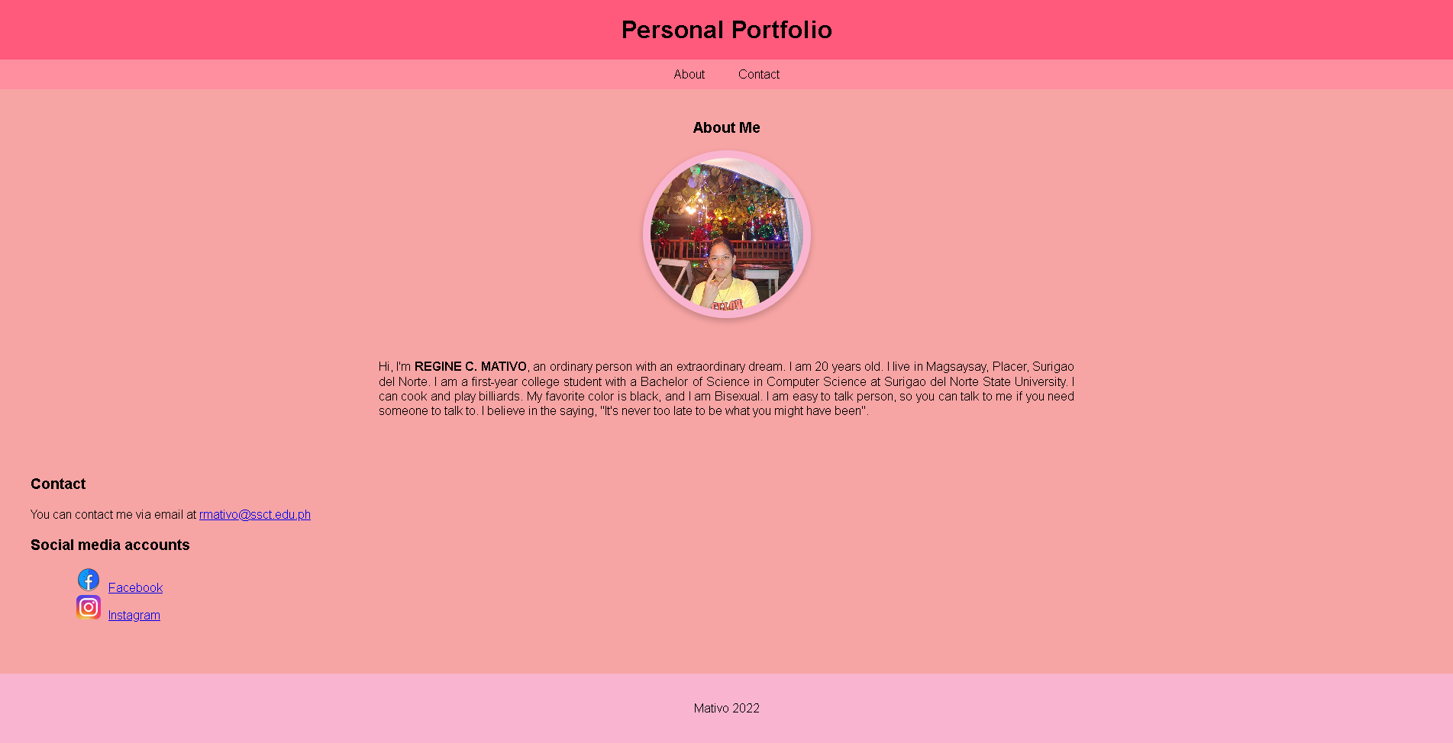

**HTML & CSS CODE:**

<!DOCTYPE html>

<html lang="en">

<head>

<meta charset="UTF-8" />

<meta http-equiv="X-UA-Compatible" content="IE=edge" />

<meta name="viewport" content="width=device-width, initial-scale=1.0" />

<title>Profile | Portfolio</title>

</head>

<style>

body {

font-family: Arial, sans-serif;

margin: 0;

padding: 0;

}

header {

background-color: #ff597b;

padding: 20px;

text-align: center;

}

h1 {

margin: 0;

}

nav {

background-color: #ff8e9e;

display: flex;

justify-content: space-around;

padding: 10px 0;

}

nav ul {

list-style: none;

margin: 0;

padding: 0;

}

nav li {

display: inline-block;

margin: 0 20px;

}

nav a {

color: black;

text-decoration: none;

}

main {

padding-left: 20px;

padding-right: 20px;

background-color: #f7a4a4;

height: 79vh;

}

.prof img {

border-radius: 50%;

width: 200px;

height: 200px;

object-fit: cover;

display: block;

margin: 0 auto;

border: 10px solid #f9b5d0;

box-shadow: 0 4px 8px 0 rgba(0, 0, 0, 0.2);

}

section {

padding: 20px;

}

#about {

display: flex;

align-items: center;

flex-direction: column;

}

#about p {

text-align: justify;

}

#about p span {

font-weight: bolder;

text-transform: uppercase;

}

#about .bio {

width: 50%;

}

#contact ul li {

position: relative;

display: flex;

align-items: center;

margin: 0 20px;

}

#contact img {

width: 32px;

margin-right: 10px;

}

footer {

background-color: #f9b5d0;

padding: 20px;

text-align: center;

}

@media (max-width: 600px) {

main {

width: 90%;

margin: 0 auto;

}

#about .bio {

width: 100%;

}

body {

background-color: #f7a4a4;

}

}

</style>

<body>

<header>

<h1>Personal Portfolio</h1>

</header>

<nav>

<ul>

<li><a href="#about">About</a></li>

<li><a href="#contact">Contact</a></li>

</ul>

</nav>

<main>

<section id="about">

<h3>About Me</h3>

<div class="prof"><img src="prof.jpg" alt="Profile" /></div>

<div class="bio">

<p>

<br /><br />

Hi, I'm <span>Regine C. Mativo</span>, an ordinary person with an

extraordinary dream. I am 20 years old. I live in Magsaysay, Placer,

Surigao del Norte. I am a first-year college student with a Bachelor

of Science in Computer Science at Surigao del Norte State

University. I can cook and play billiards. My favorite color is

black, and I am Bisexual. I am easy to talk person, so you can talk

to me if you need someone to talk to. I believe in the saying, "It's

never too late to be what you might have been".

</p>

</div>

</section>

<section id="contact">

<h3>Contact</h3>

<p>

You can contact me via email at

<a href="rmativo@ssct.edu.ph">rmativo@ssct.edu.ph</a>

</p>

<h3>Social media accounts</h3>

<ul>

<li>

<a href="https://facebook.com/Pahakjejed/"

><img src="facebook.png" alt="facebook" />Facebook</a

>

</li>

<li>

<a href="https://instagram.com/reginemativo/">

<img src="insta.png" alt="instagram" />Instagram</a

>

</li>

</ul>

</section>

</main>

<footer>

<p>Mativo 2022</p>

</footer>

</body>

</html>